**Lab Exercise 22**

**Checking Vulnerabilities Using Trivy**

**Objective:** To scan container images for vulnerabilities using Trivy to identify and mitigate security risks and ensure that containerized applications are secure

**Tools required:** Trivy

**Prerequisites:** None

Steps to be followed:

1. Install Trivy
2. Scan the vulnerabilities using Trivy

**Step 1: Install Trivy**

1. Run the following command to install tools for secure downloads, HTTPS repositories, encryption key management, and system version identification:   
   brew install trivy

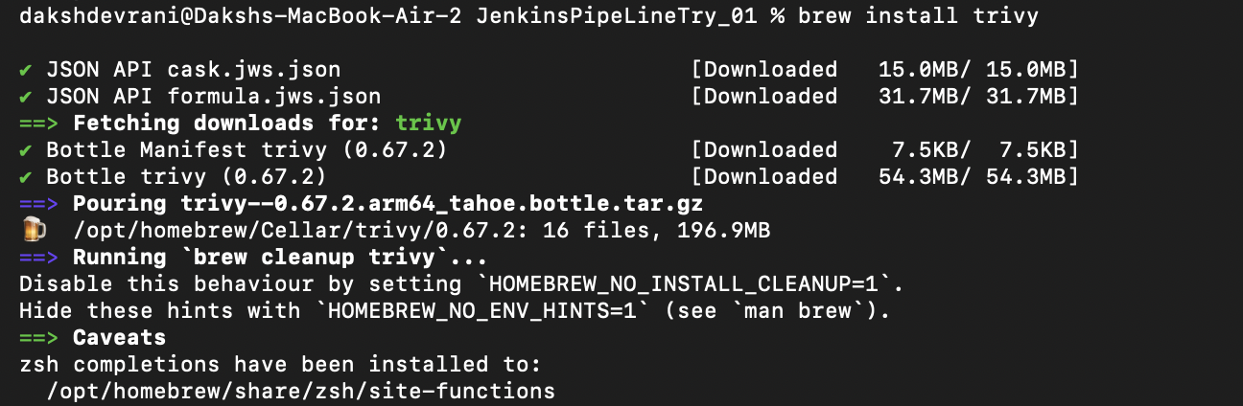

**Step 2: Scan the vulnerabilities using Trivy**

1. Run the following command to scan the NGINX container image with Trivy for vulnerabilities and security issues:

**trivy image nginx**  
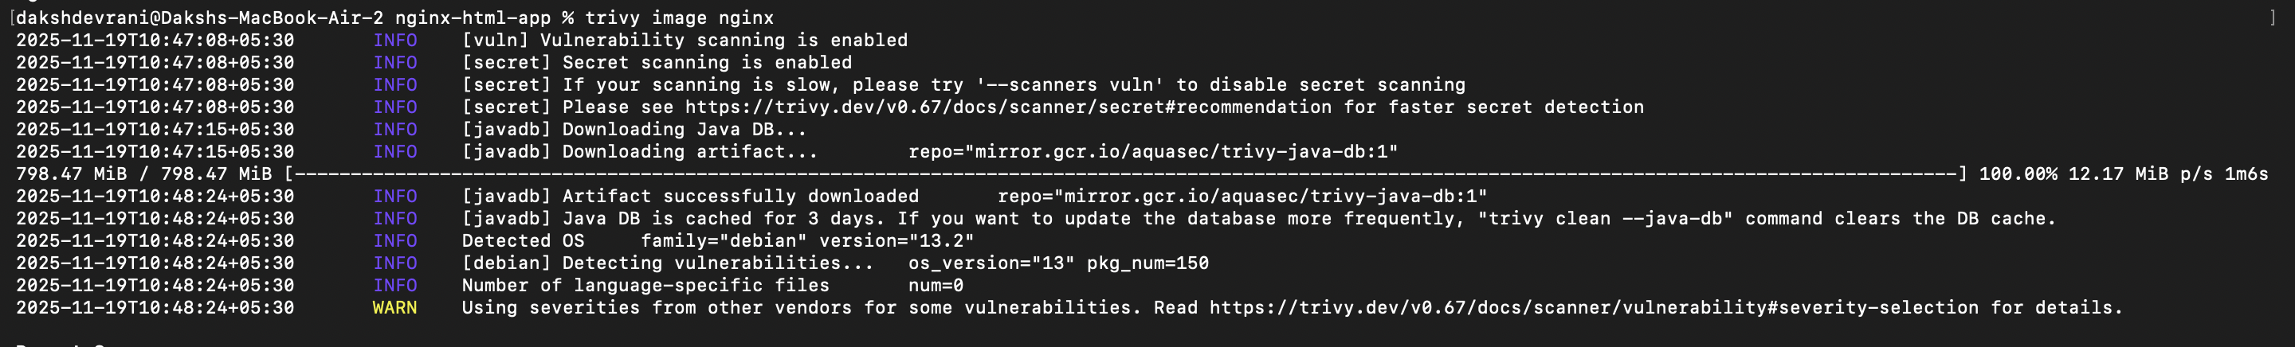  
  
  
It shows the results of a Trivy security scan, listing vulnerabilities in installed packages, their severity, and whether they are affected. It also includes details like the installed version and links for more information.

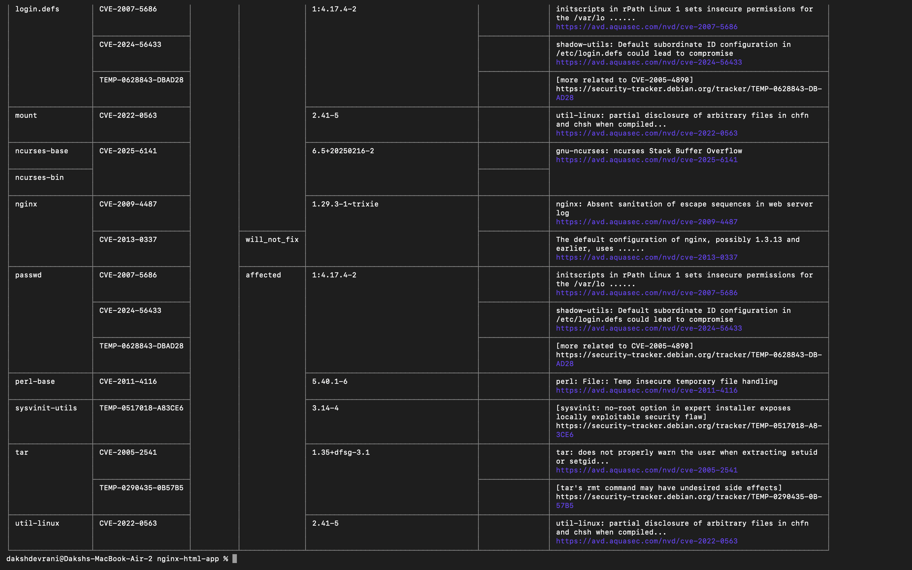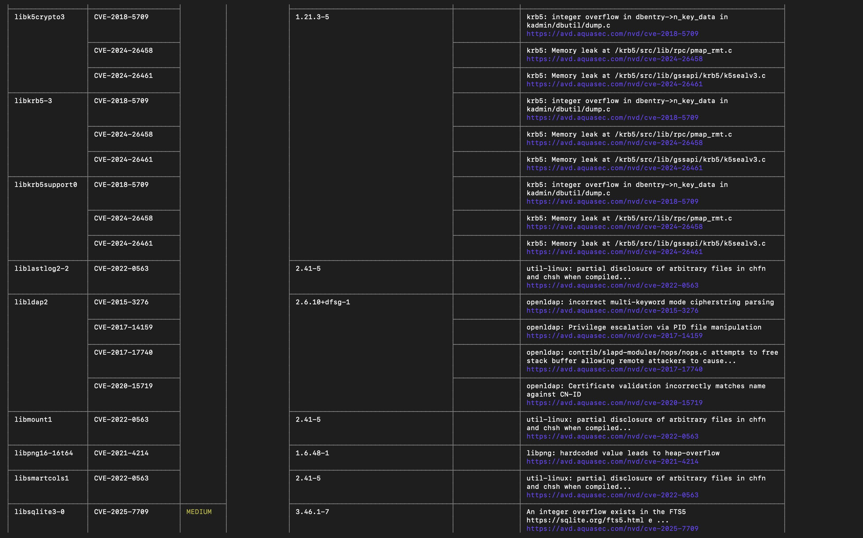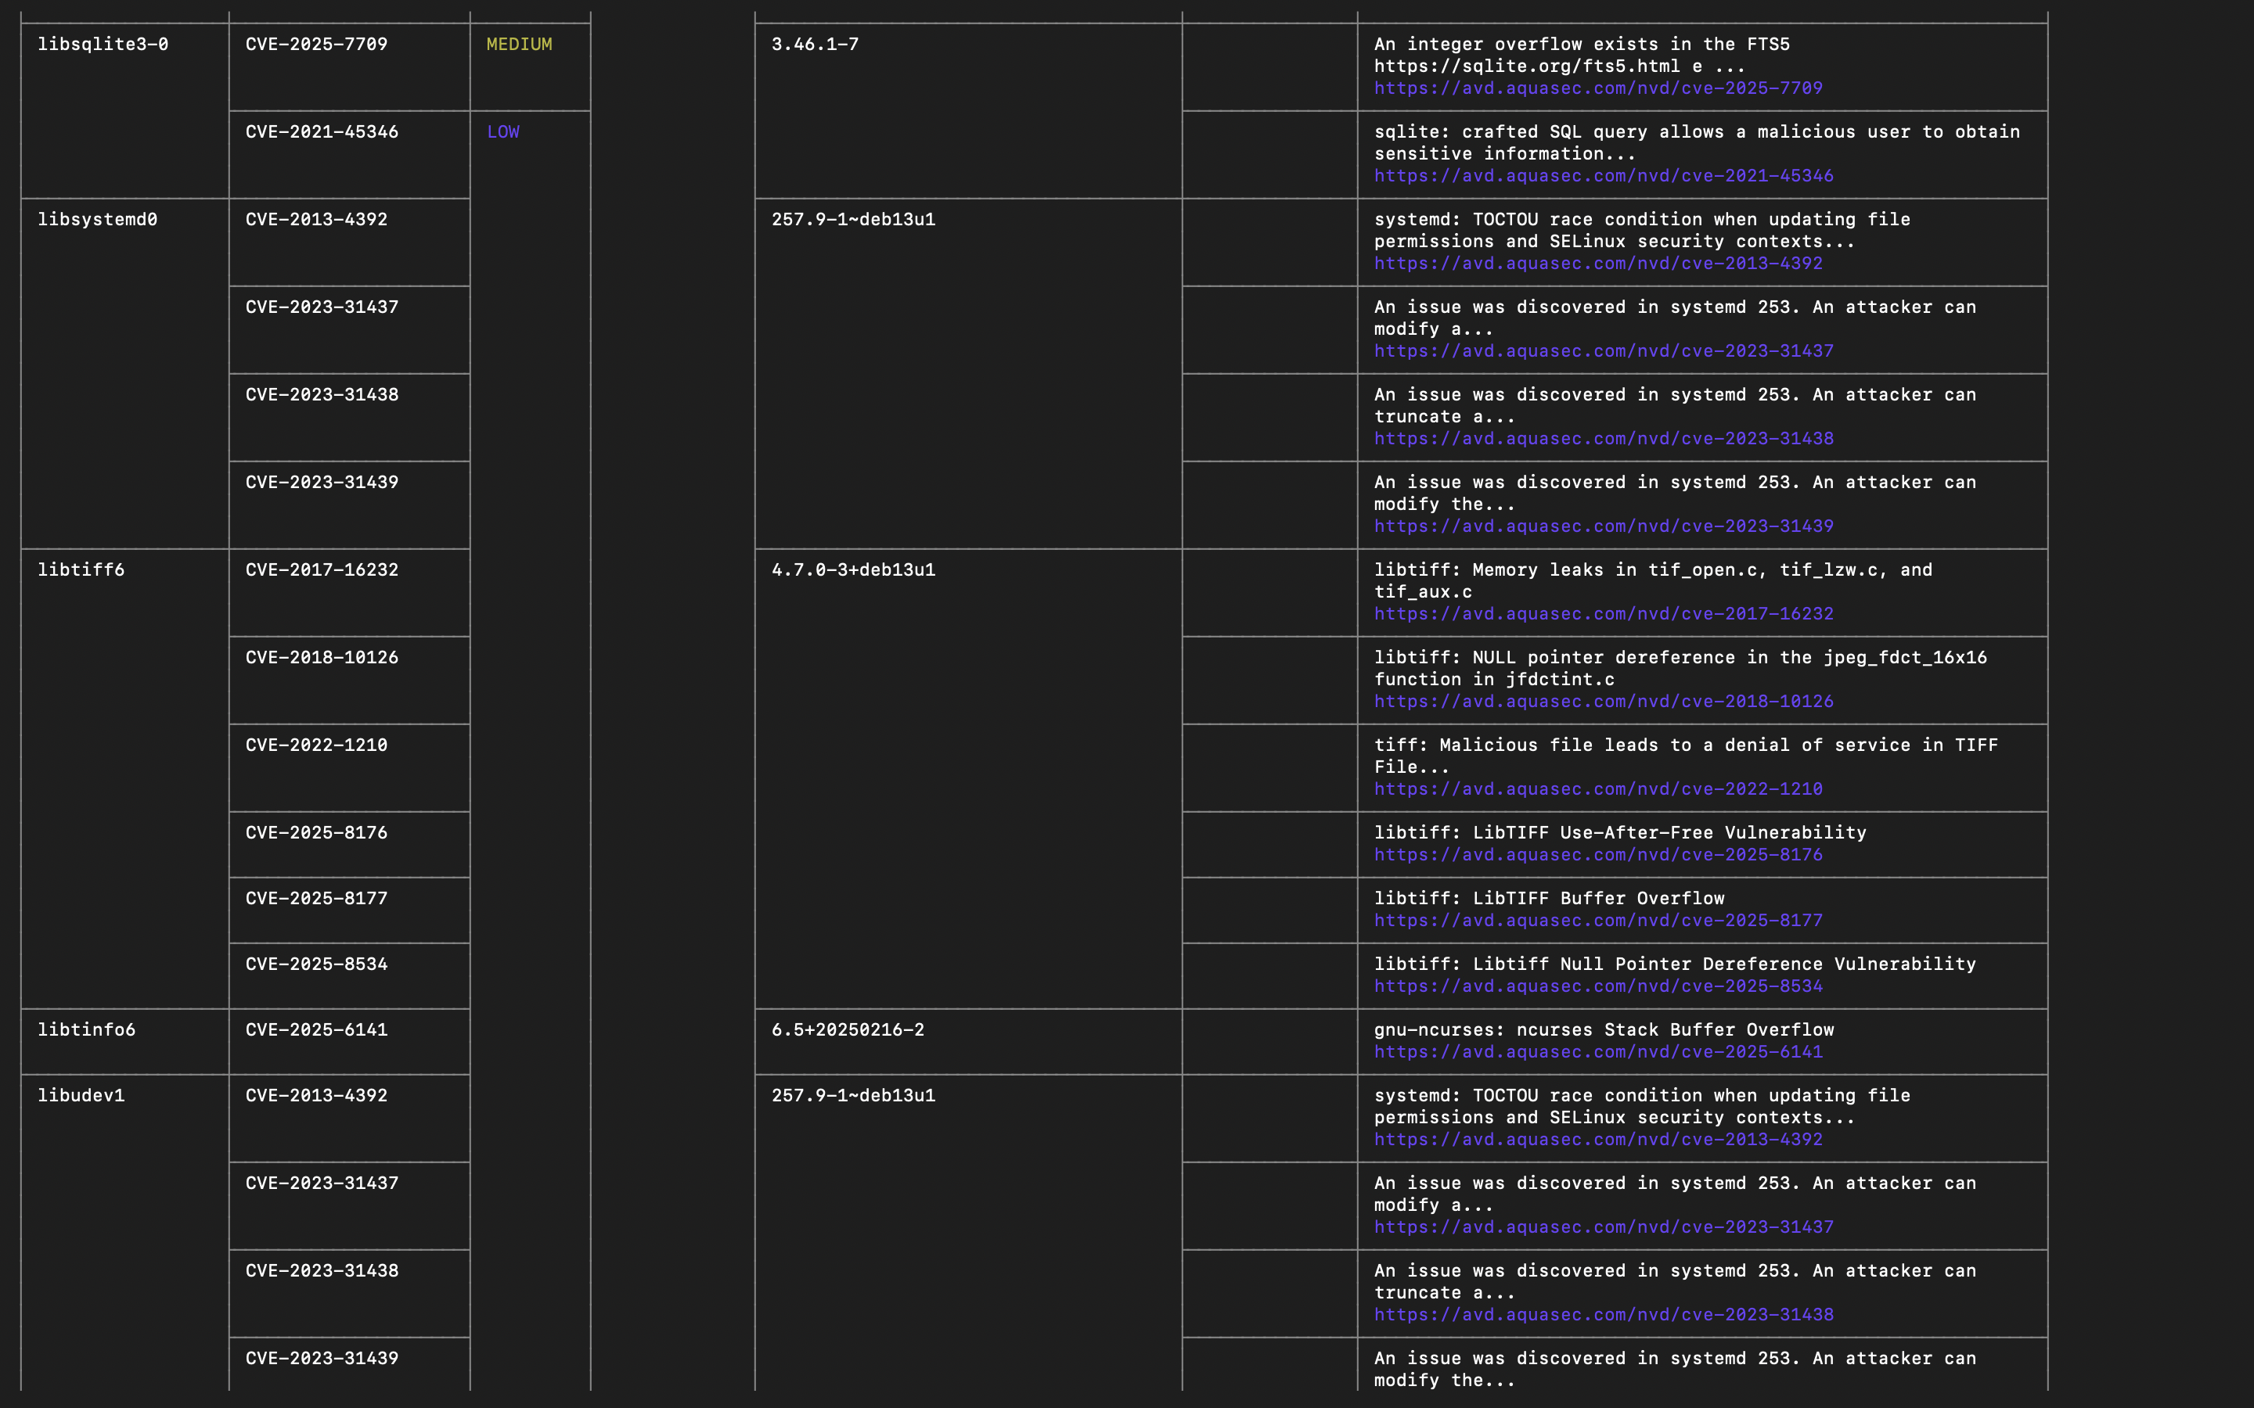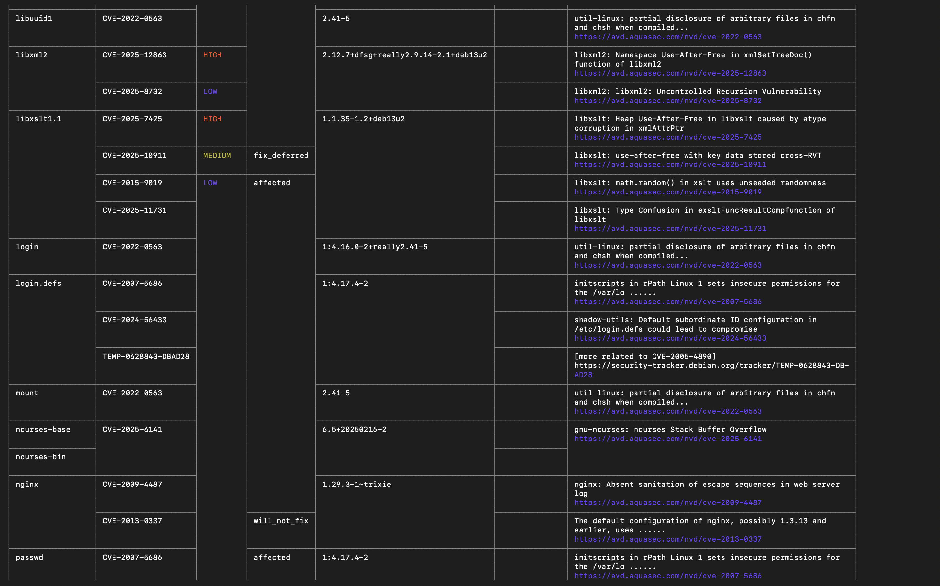  
  
By following these steps, you have successfully scanned container images for vulnerabilities using Trivy to identify and mitigate security risks and ensure the security of containerized applications.